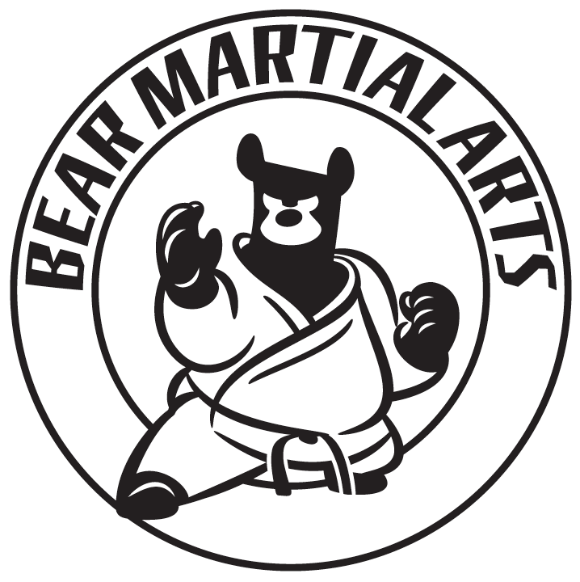

Bear Martial Arts Corporate Services Query Form

Name

Position

Company

Email Address

Estimated number of attendees

Can you provide a venue for the session?

Do you have a preference for any of the following sessions:
- Self Defence 101
- Knife Defences
- Qi Gong / Tai Chi
- Martial Arts Fitness

Any special requests?

Please complete this form and email it back to us at team@bearmartialarts.com, and we will email you back with a quote for your day.

